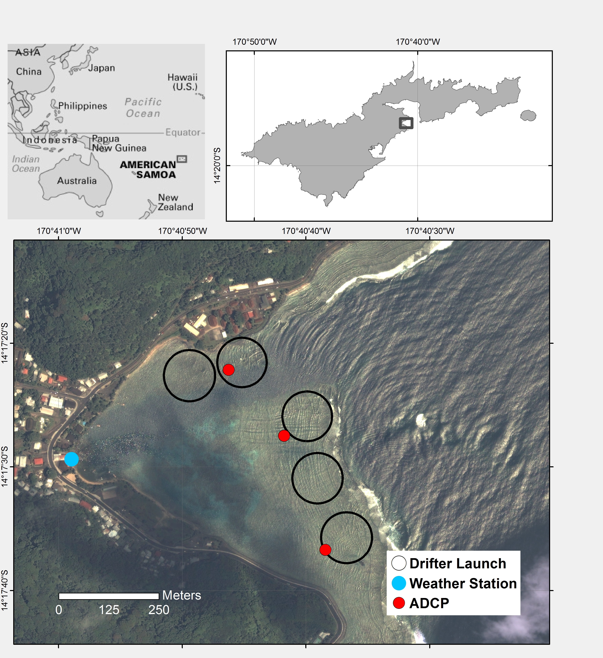

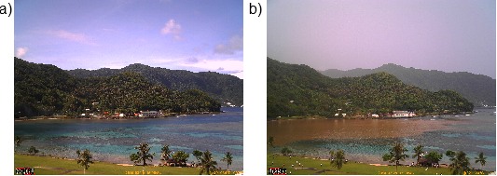

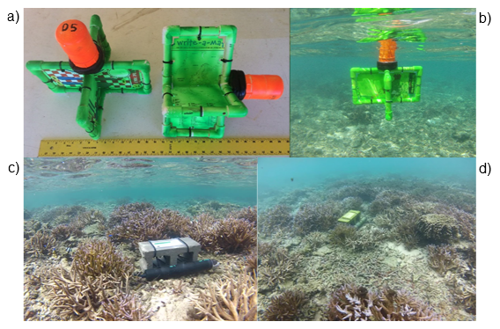

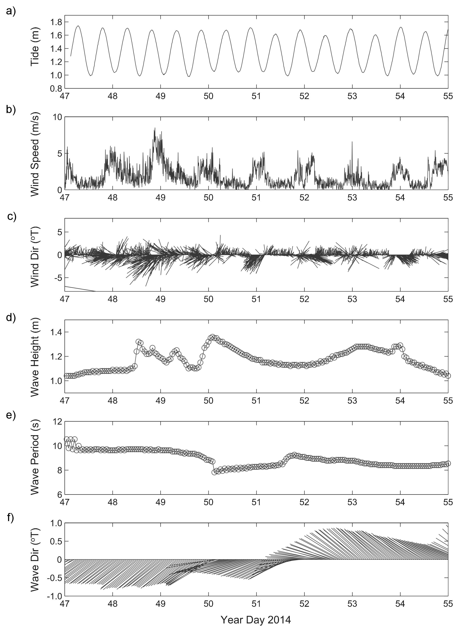

|  |  |  |  |
| --- | --- | --- | --- |
| Table 1. End member periods | | | |
| End member | Year Day 2014 | Gregorian Day (UTC) | Gregorian Day (Local) |
| Tide/Calm | 50-51 | 2/19-2/20 | 2/18-2/19 |
| Wind | 47-49 | 2/16-2/18 | 2/15-2/17 |
| Wave | 52-55 | 2/21-2/24 | 2/20-2/23 |

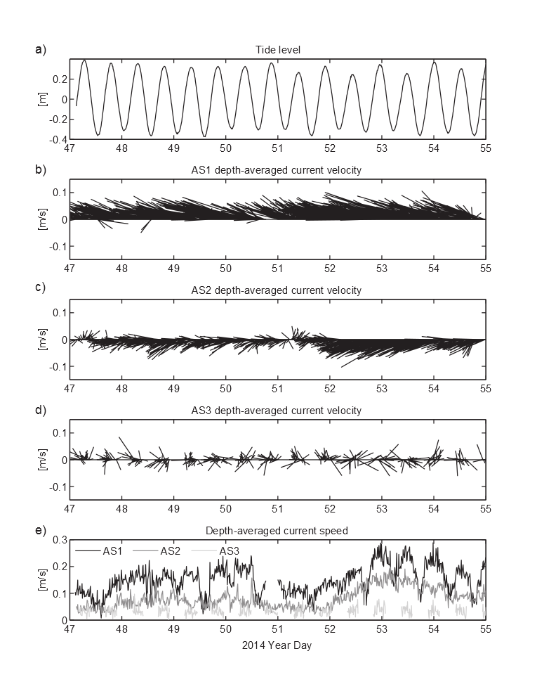

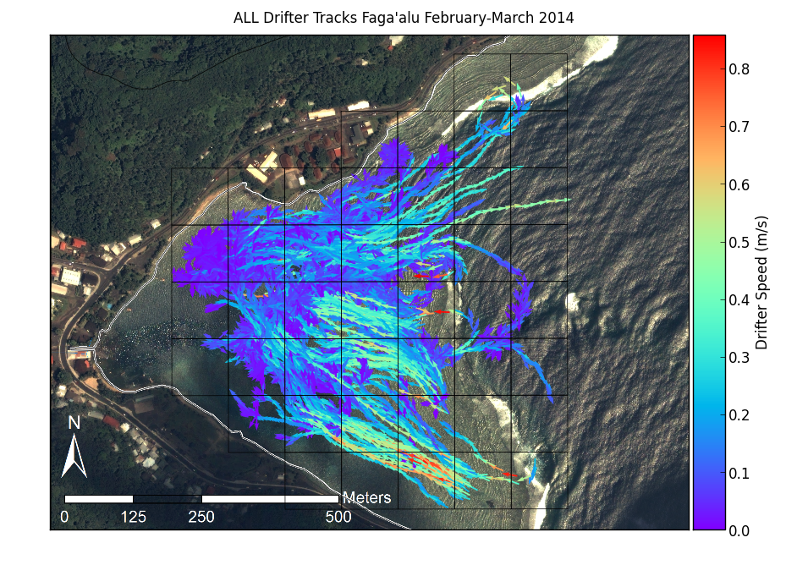

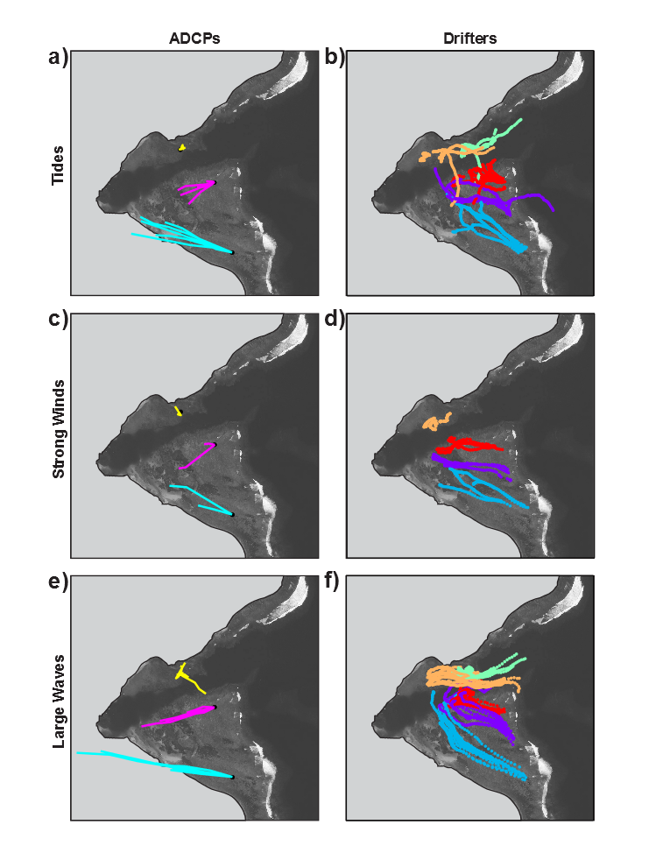

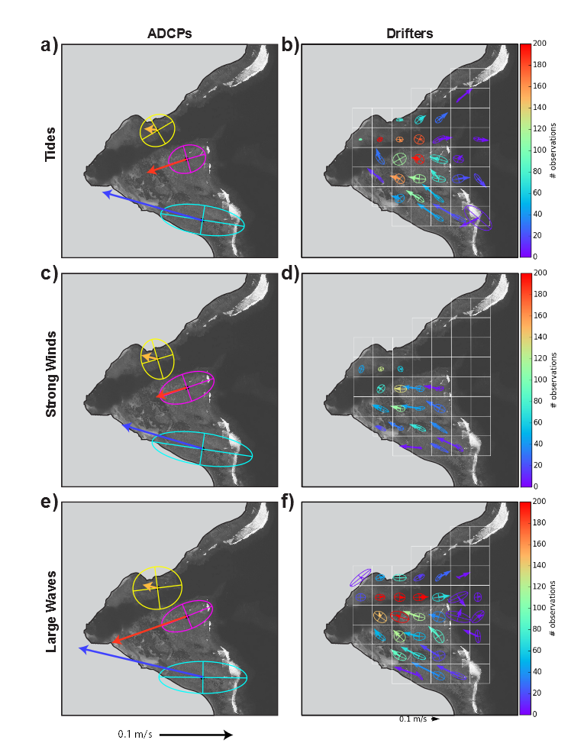

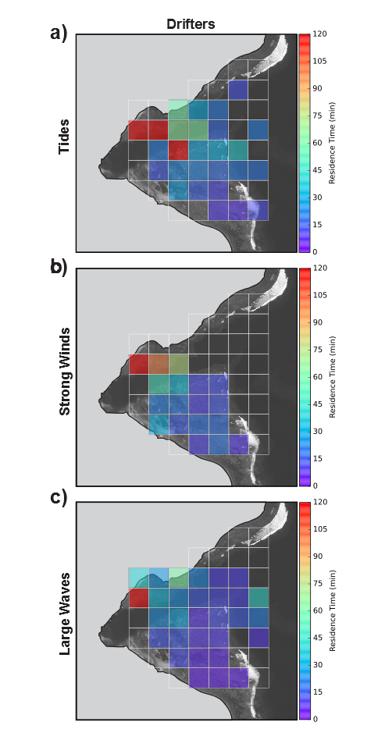



|  |  |  |  |  |  |  |  |  |  |  |
| --- | --- | --- | --- | --- | --- | --- | --- | --- | --- | --- |
| Table 1. Drifter deployment dates and conditions. Red numbered Deployments coincide with ADCP deployment | | | | | | | | | | |
| Deployment | Year Day 2014 (local) | Start Time | End Time | Tide Start m | Tide End m | Tide movement m | Wind Speed Avg m/s | Wind Gust Max m/s | Wind Direction Avg deg | Wave Height m |
| 1 | 19 | 1300 | 1500 | 1.5 | 0.3 | -0.17 | 0.6 | 2.0 | 232 | 0.0-0.6 |
| 2 | 20 | 1615 | 1730 | 1.0 | 0.4 | 0.06 | 1.2 | 4.0 | 193 | 0.3-0.6 |
| 3 | 20 | 1750 | 1900 | 1.2 | 0.6 | 0.22 | 1.7 | 5.0 | 258 | 0.3-0.6 |
| 4 | 32 | 900 | 1100 | 3.7 | 0.8 | -0.35 | 2.7 | 6.0 | 96 | 0-0.3 |
| 5 | 32 | 1130 | 1300 | 2.2 | 0.3 | -0.41 | 2.9 | 7.0 | 100 | 0-0.3 |
| 6 | 32 | 1700 | 1900 | 1.5 | 1.0 | 0.52 | 2.2 | 7.0 | 187 | 0-0.3 |
| 7 | 39 | 1415 | 1545 | 3.1 | 1.1 | 0.11 | 2.7 | 9.0 | 140 | 0.6-1.3 |
| 8 | 39 | 1605 | 1800 | 3.3 | 0.8 | -0.24 | 3.1 | 10.0 | 144 | 0.6-1.3 |
| 9 | 47 | 1654 | 1846 | 2.4 | 1.0 | 0.26 | 1.7 | 5.0 | 168 | 0.0-0.6 |
| 10 | 48 | 1245 | 1500 | 1.6 | 0.3 | -0.16 | 5.0 | 14.0 | 79 | 0.6-1.3 |
| 11 | 48 | 1530 | 1700 | 1.1 | 0.5 | 0.14 | 3.0 | 10.0 | 101 | 0.6-1.3 |
| 12 | 48 | 1710 | 1840 | 1.6 | 0.8 | 0.29 | 2.7 | 8.0 | 89 | 0.6-1.3 |
| 13 | 49 | 1245 | 1445 | 2.1 | 0.4 | -0.25 | 2.5 | 7.0 | 97 | 0.6-1.3 |
| 14 | 49 | 1445 | 1700 | 1.3 | 0.4 | 0.02 | 2.4 | 8.0 | 194 | 0.6-1.3 |
| 15 | 50 | 1205 | 1440 | 2.9 | 0.5 | -0.42 | 3.0 | 6.0 | 39 | 0.6-1.3 |
| 16 | 50 | 1445 | 1720 | 1.5 | 0.4 | -0.08 | 3.4 | 8.0 | 54 | 0.6-1.3 |
| 17 | 51 | 840 | 1045 | 2.5 | 1.0 | 0.19 | 2.5 | 7.0 | 290 | 0.0-0.6 |
| 18 | 51 | 1100 | 1200 | 3.2 | 0.9 | -0.05 | 2.2 | 6.0 | 117 | 0.0-0.6 |
| 19 | 51 | 1210 | 1430 | 3.0 | 0.6 | -0.29 | 1.5 | 6.0 | 237 | 0.0-0.6 |
| 20 | 51 | 1500 | 1630 | 1.8 | 0.4 | -0.17 | 3.1 | 7.0 | 290 | 0.0-0.6 |
| 21 | 52 | 920 | 1040 | 2.4 | 0.9 | 0.18 | 1.5 | 6.0 | 253 | 1.0-2.0 |
| 22 | 52 | 1040 | 1145 | 3.0 | 1.0 | 0.09 | 2.0 | 6.0 | 111 | 1.0-2.0 |
| 23 | 52 | 1300 | 1400 | 3.2 | 0.9 | -0.08 | 1.5 | 8.0 | 193 | 1.0-2.0 |
| 24 | 52 | 1500 | 1550 | 2.4 | 0.6 | -0.16 | 1.9 | 6.0 | 152 | 1.0-2.0 |
| 25 | 53 | 1100 | 1215 | 2.7 | 1.0 | 0.14 | 2.8 | 7.0 | 313 | 1.0-2.0 |
| 26 | 53 | 1220 | 1315 | 3.2 | 1.0 | 0.05 | 3.3 | 6.0 | 301 | 1.0-2.0 |
| 27 | 53 | 1600 | 1700 | 2.4 | 0.6 | -0.16 | 2.1 | 5.0 | 310 | 1.0-2.0 |
| 28 | 53 | 1700 | 1845 | 1.9 | 0.4 | -0.22 | 1.0 | 5.0 | 242 | 1.0-2.0 |
| 29 | 54 | 1040 | 1210 | 2.0 | 0.9 | 0.27 | 3.7 | 8.0 | 304 | 0.6-1.3 |
| 30 | 54 | 1210 | 1255 | 2.9 | 1.0 | 0.11 | 2.7 | 6.0 | 260 | 0.6-1.3 |